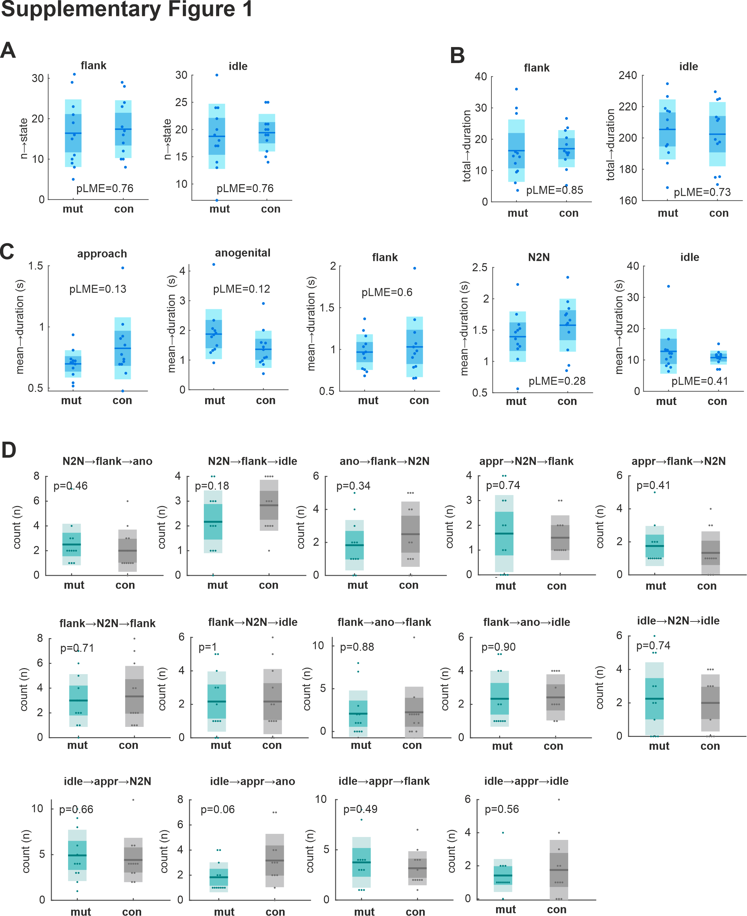

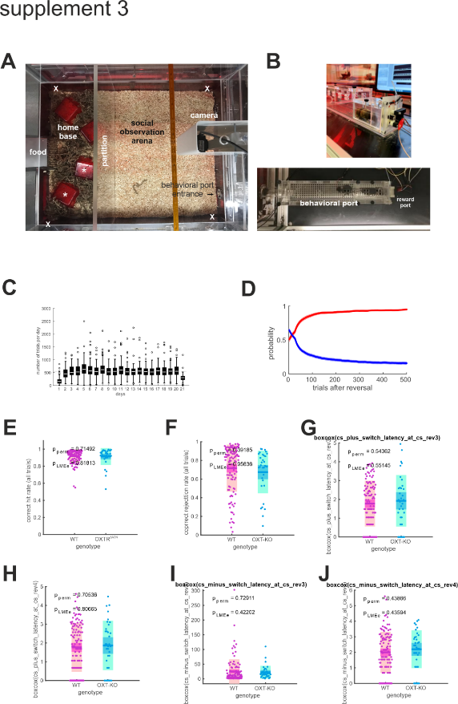

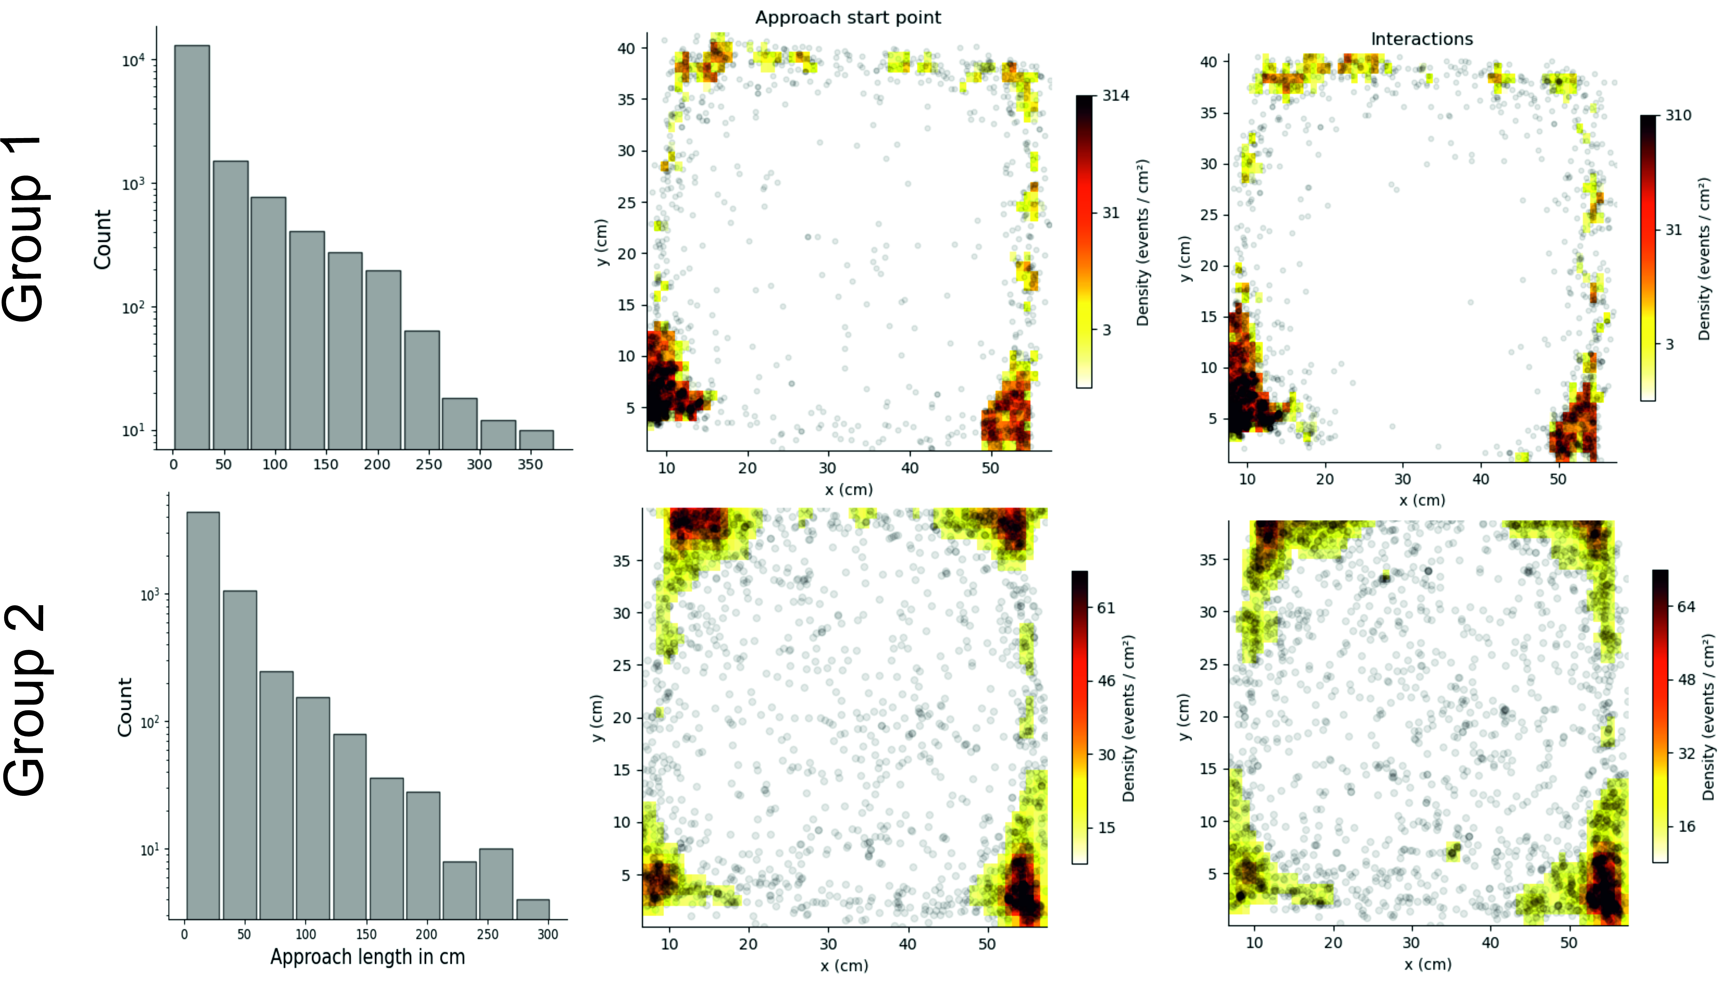

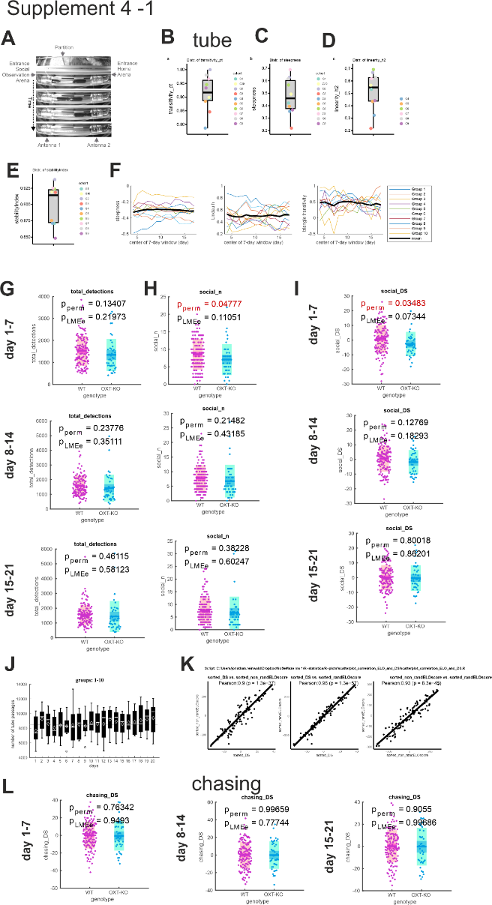

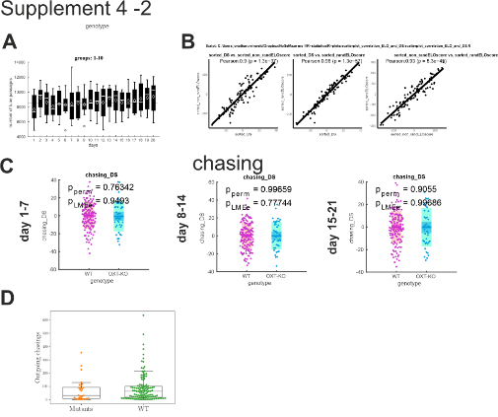

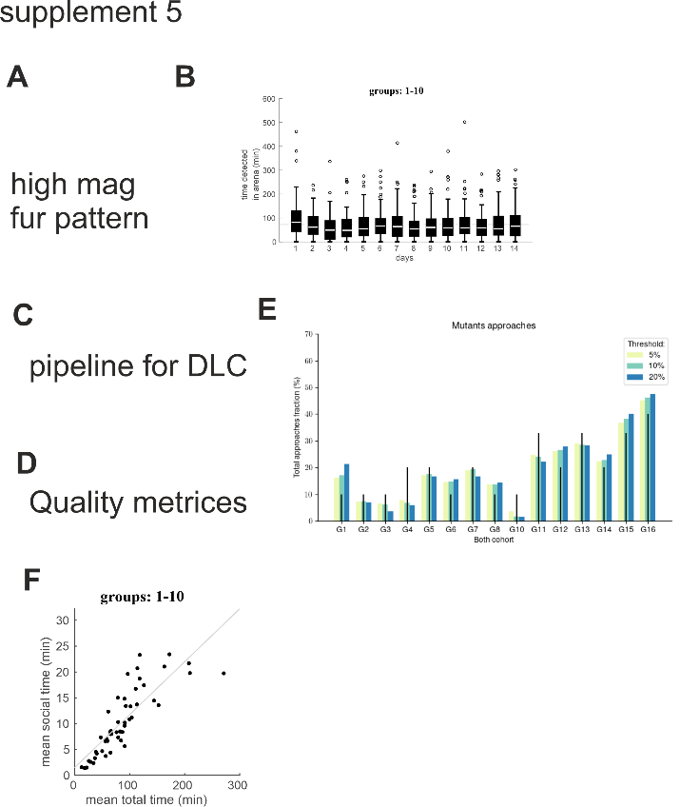

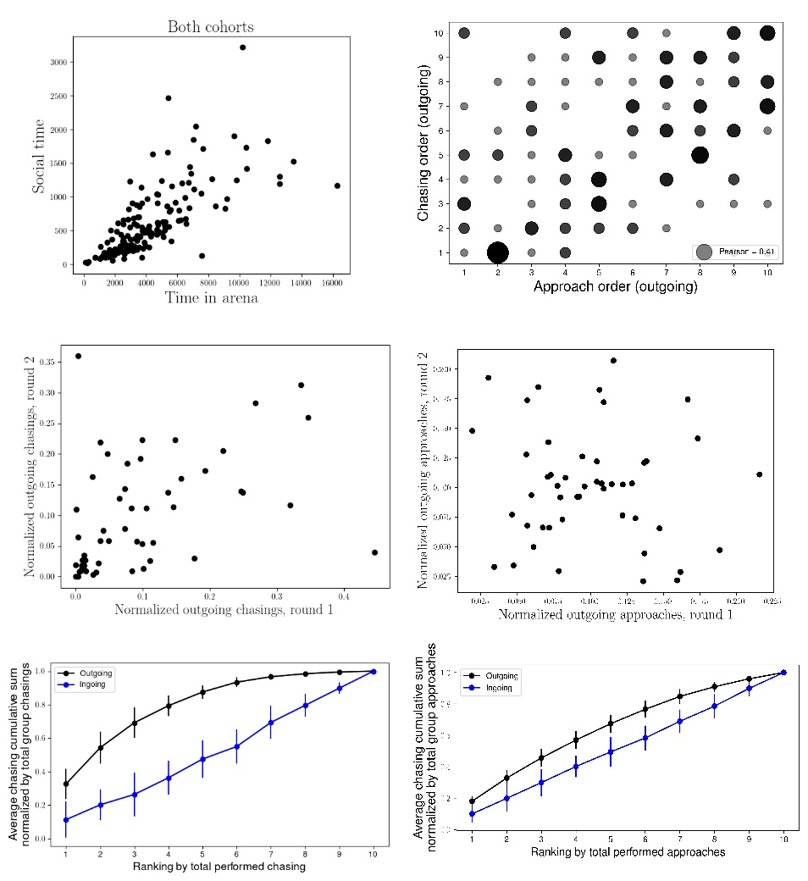

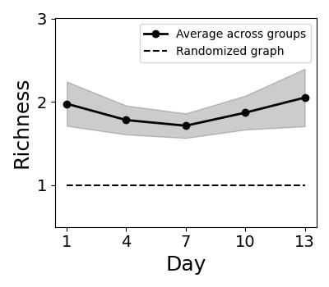

**Supplementary figure**: Normalized rich club coefficients averaged over all cohorts, displayed as a function of time. The individual graphs used for the computation were averaged as a function of time with a 3-days rolling window. The dotted line shows the average rich club coefficients, and the gray overlay shows the standard error across the different groups. For each graph, the computed rich club coefficient is normalized against a random graph having the same edge weights distribution. Normalized values higher than 1 therefore indicate the presence of structure that cannot be attributed to random chance.

Approaches

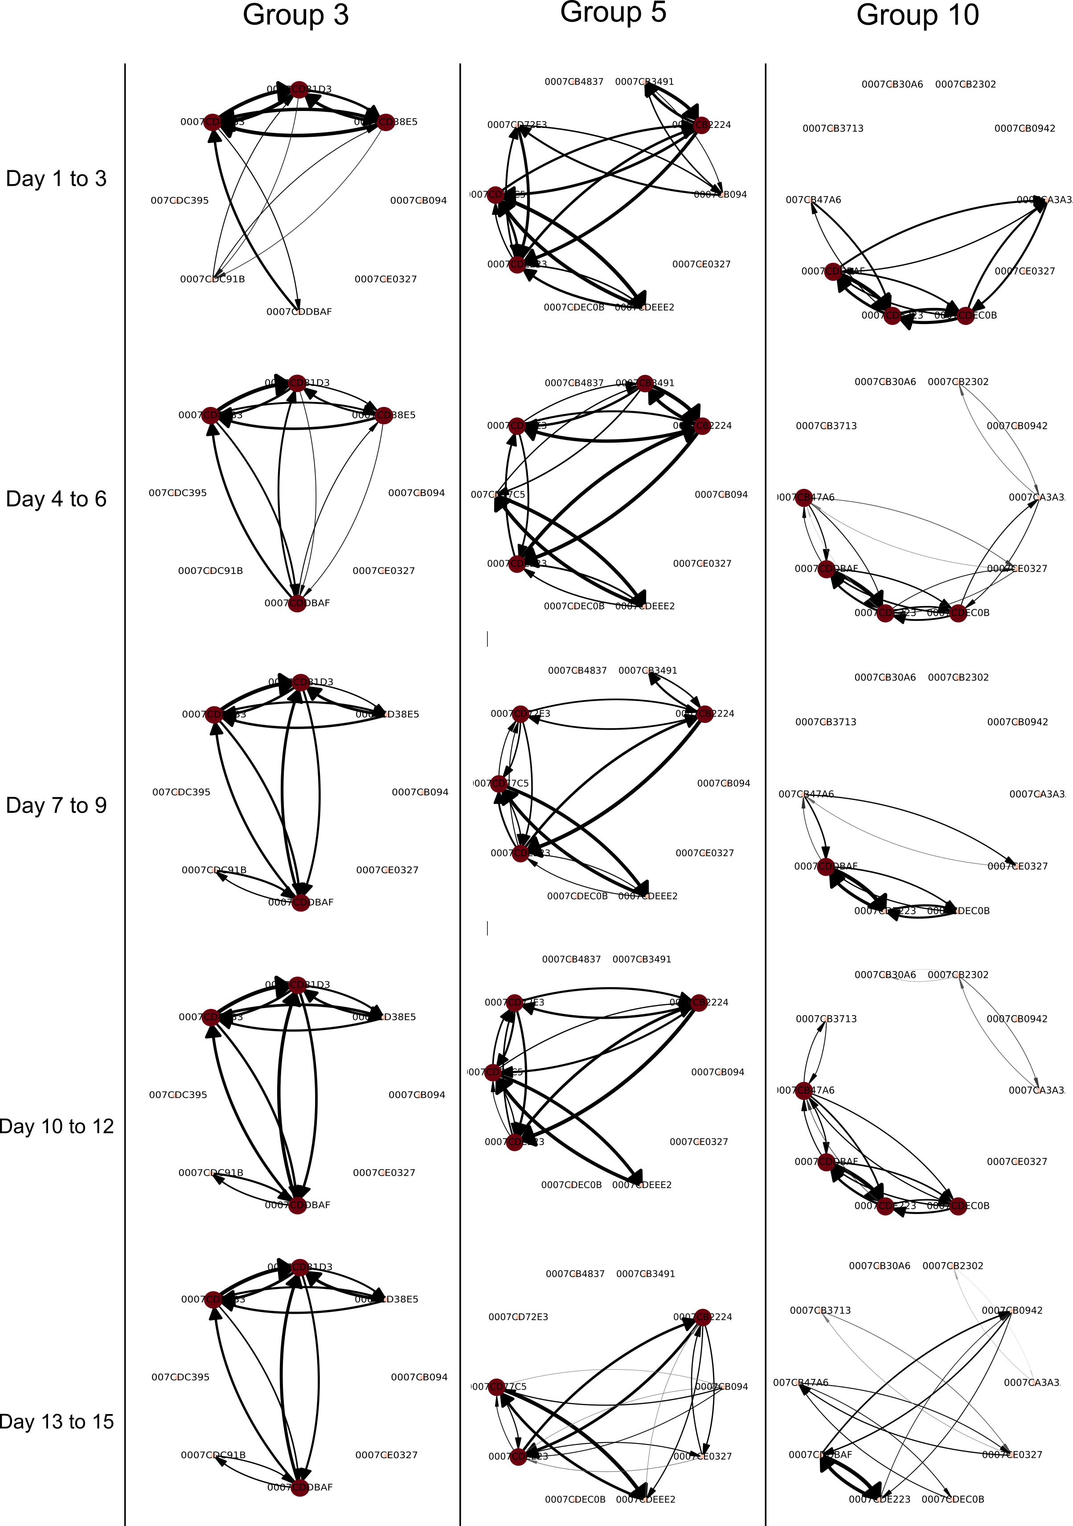

Mean interaction time

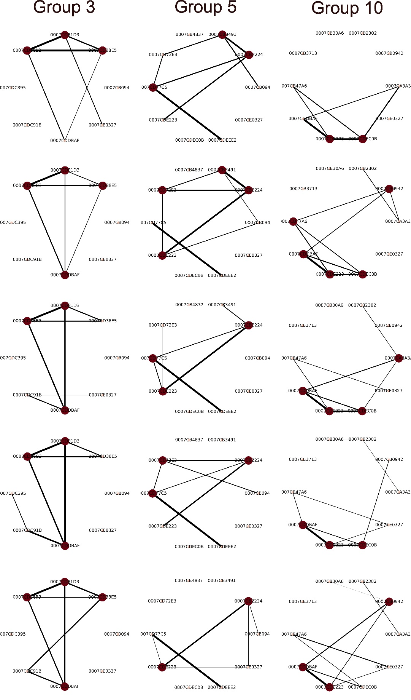

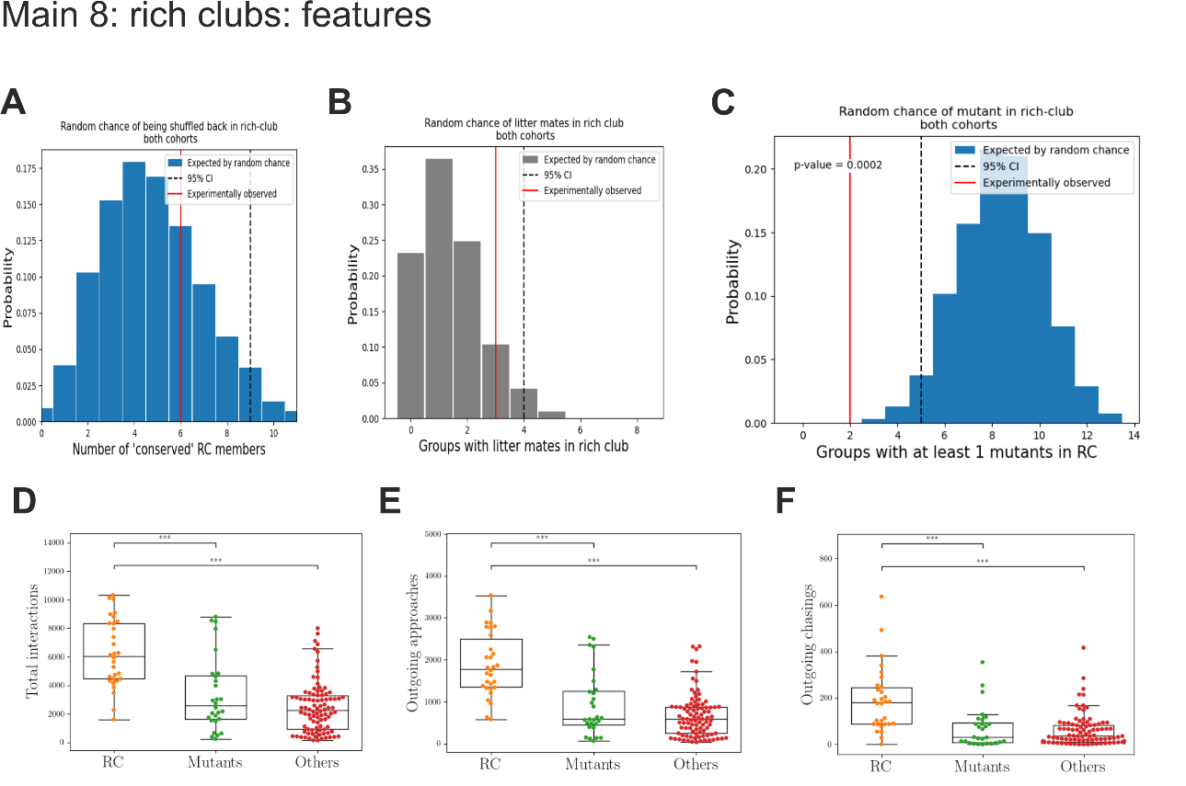

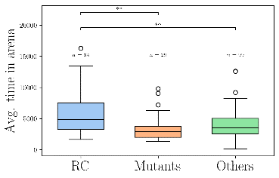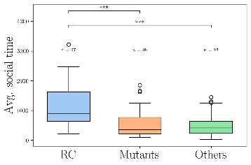

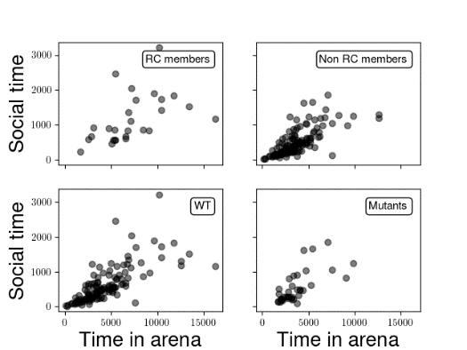

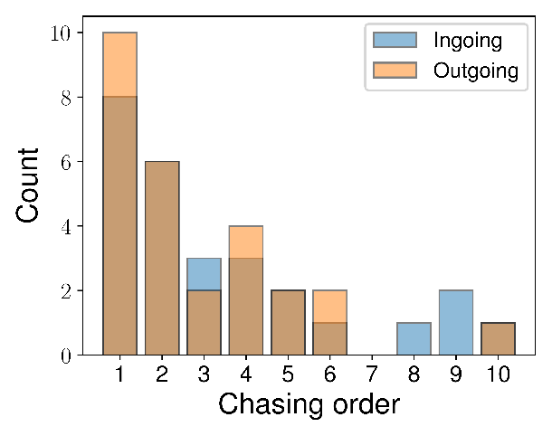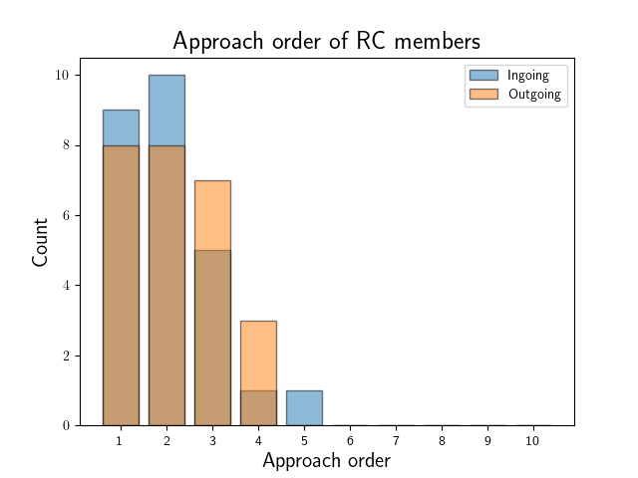

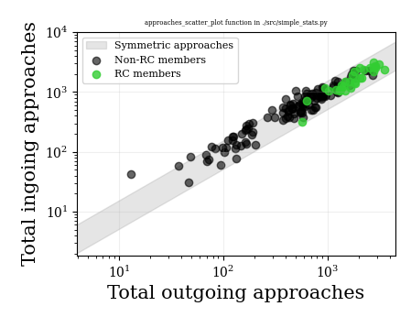

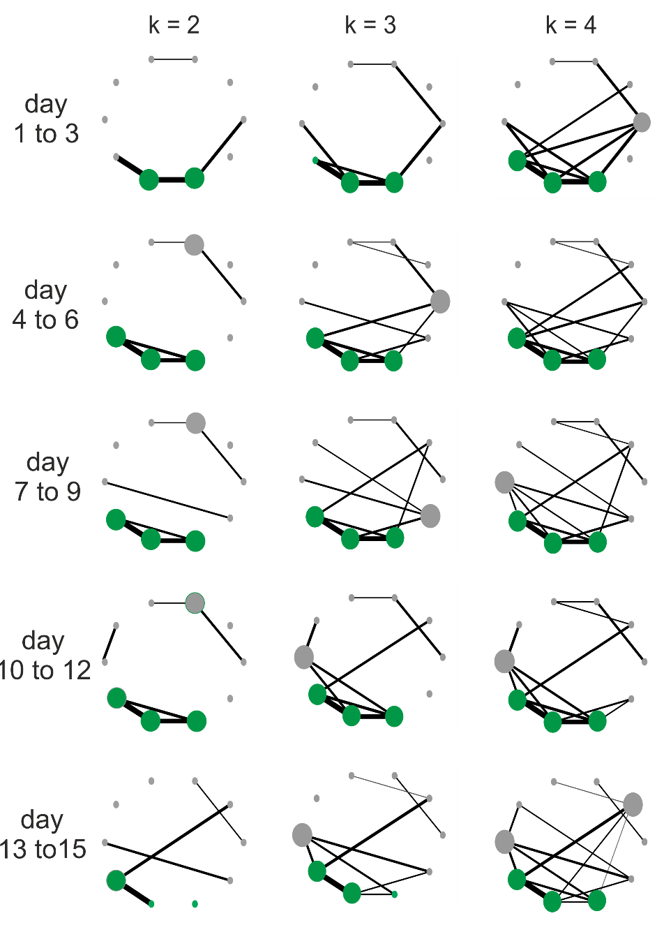

**Supplement figure: Choice of k and stability of results.** The choice of k = 3 is a good compromise between a crowded graph (k = 4) and a graph that starts to lose some of its structural features (k = 2).

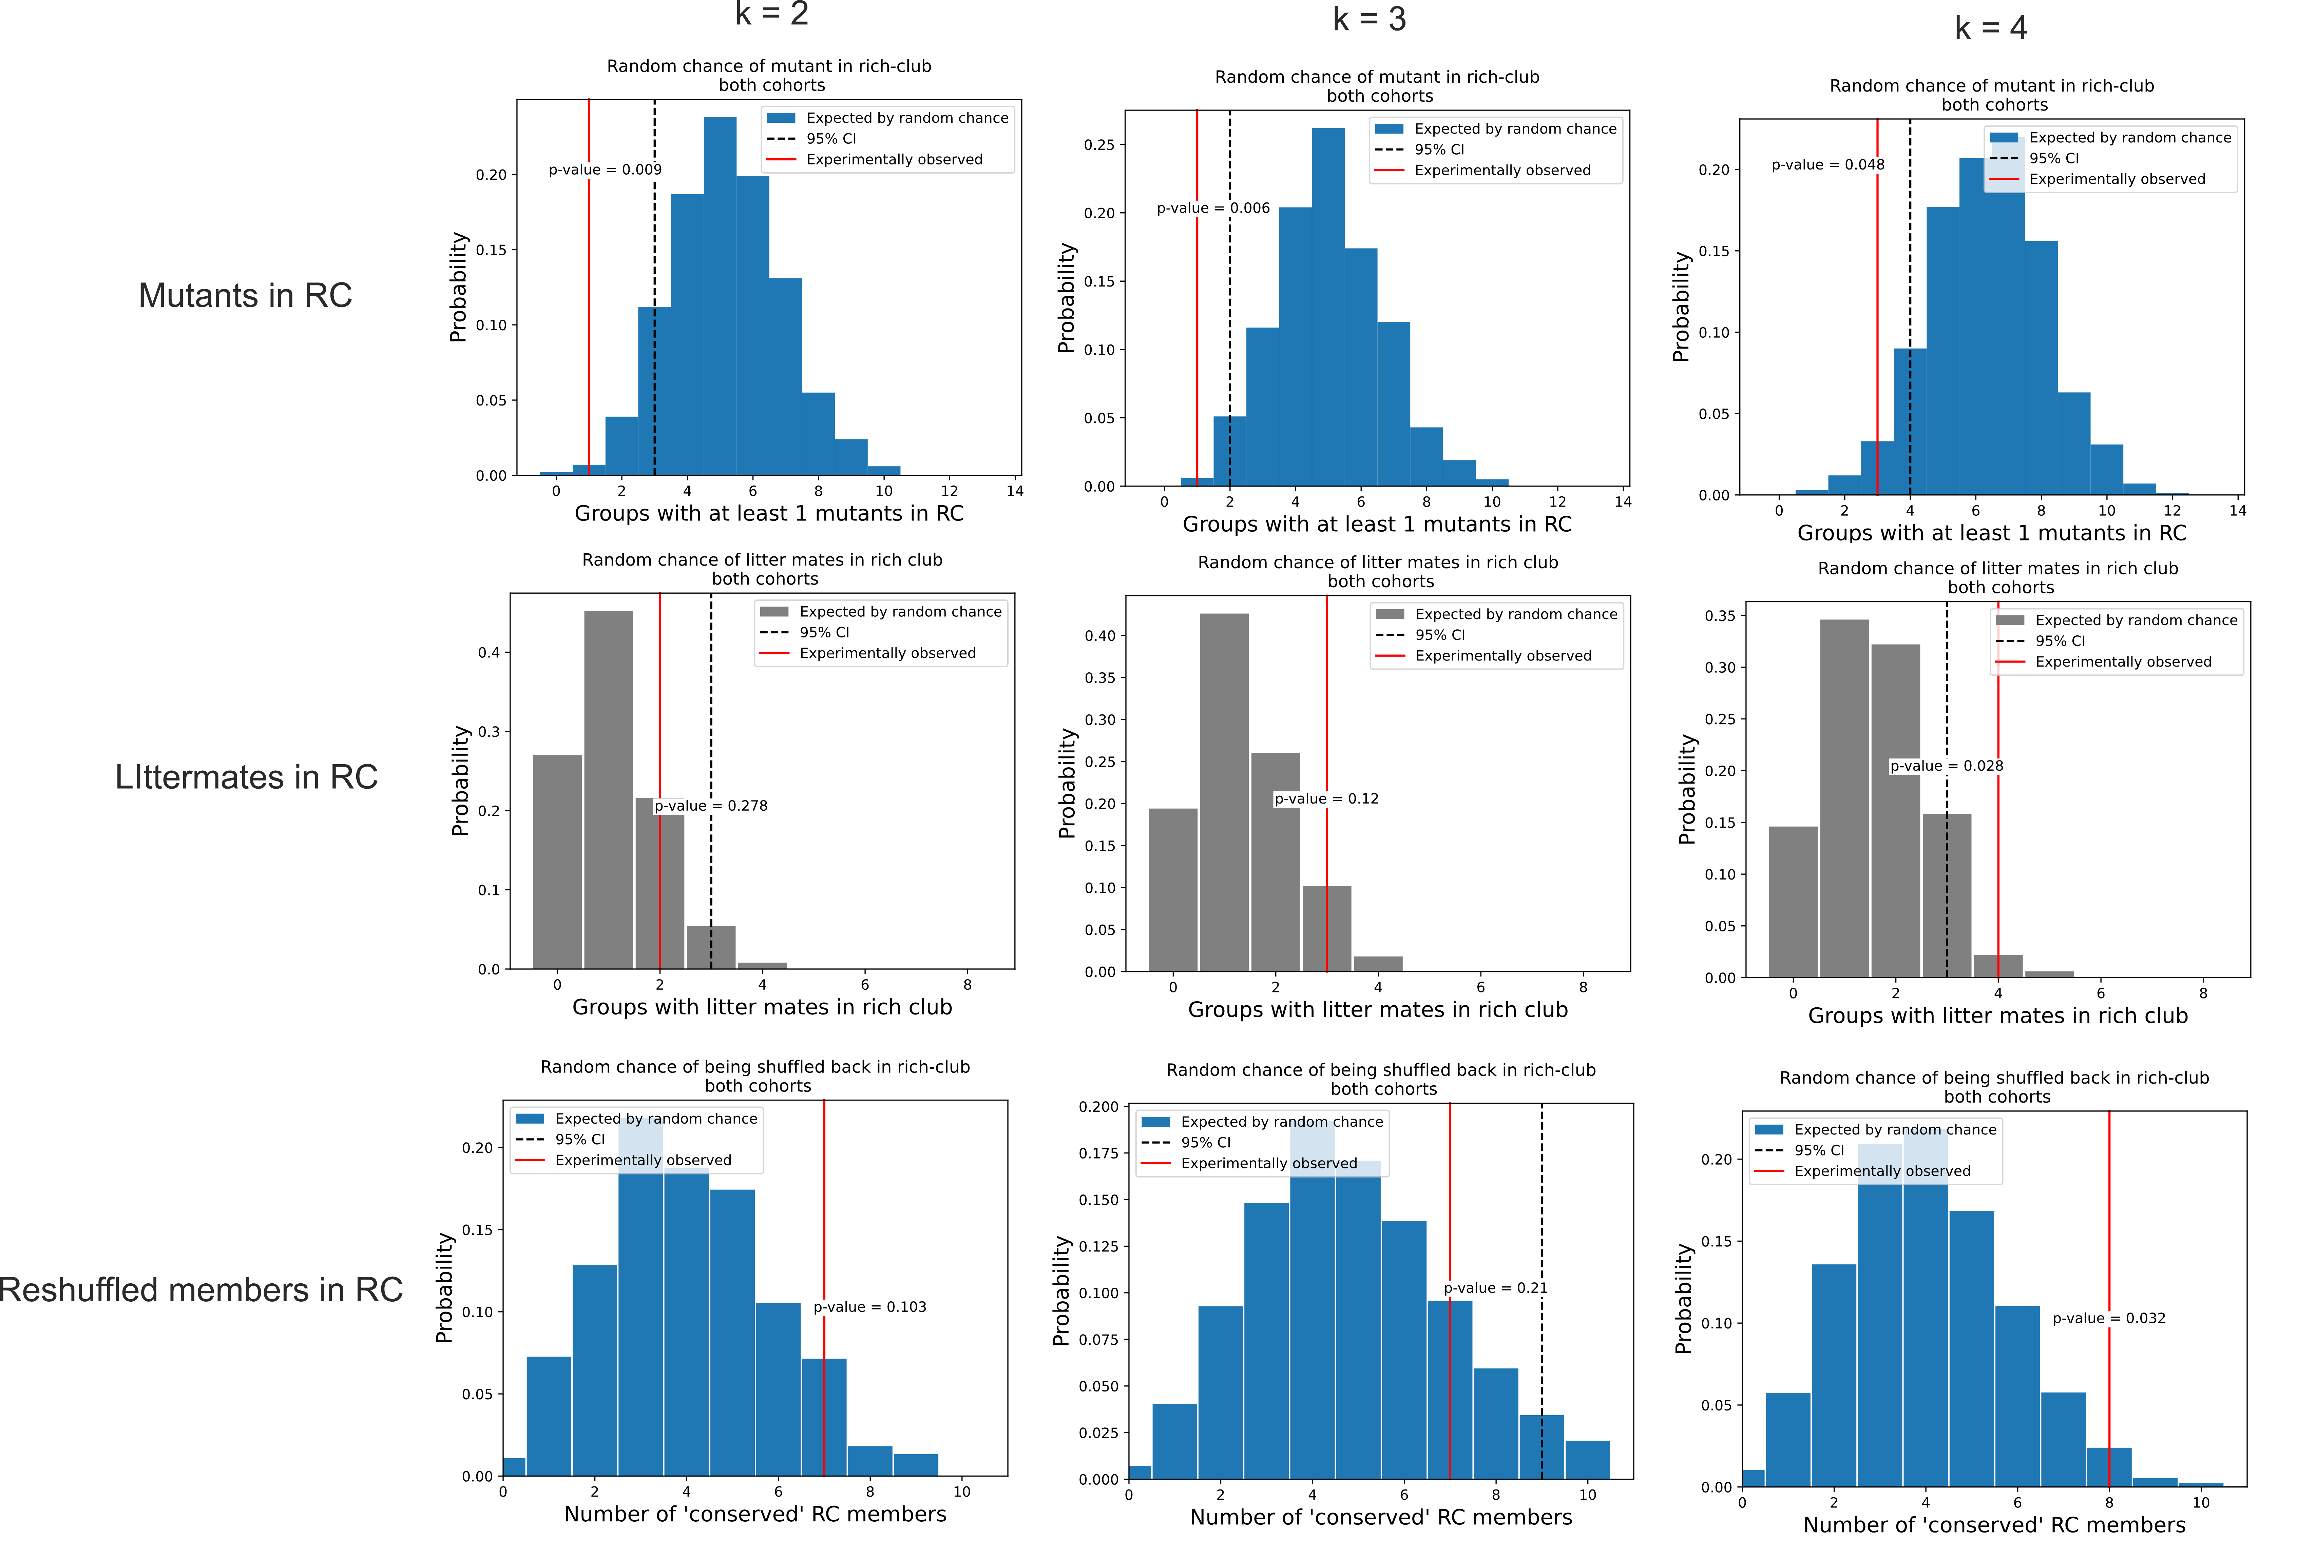

**Supplement Figure: Stability under varying values of k.** The finding that the mutants are excluded from the stable rich clubs are unaffected by the choice of parameter k used for pruning the graphs and identifying the rich clubs.